Cover Letter

Respected editors,

I, Nimish Mishra from Department of Computer Science and Engineering from Indian Institute of Information Technology, Kalyani, West Bengal, India, submit a manuscript titled *Analysis of power generation potential of large Indian wind farms using Computational Fluid Dynamics and Polynomial Regression* to the journal.

This article investigates wind power generation potential of large Indian wind farms in India using computational fluid dynamics and polynomial regression. It is found that several Indian wind farms have old, out-dated wind turbines and can greatly benefit by replacing them with state-of-the-art GE 1.5XLE turbine. This would lead to more power output from wind, thereby benefitting the economy.The prime reason to undertake this project was the lack of research investigating if the *existing* wind turbines in India produce power to their full potential. Most projects either focussed on socio-economic constraints on setting up new wind projects or on wind turbine design principles from an engineering point of view. It was therefore felt necessary to quantitatively establish the fact that a revamp drive across various wind farms in India is needed urgently, keeping in mind that India aims to shift towards renewable sources of energy for its power demand.

I feel the article conforms to the journal’s aim and scope *to support the transition to a low carbon future* by considering wind energy having *significant review element* in form of an analysis and comparison.

This is a full length article with word count 5948. It is uploaded as a preprint on ResearchGate on the author’s profile at <https://www.researchgate.net/publication/331174358_Draft_3_Analysis_of_power_generation_potential_of_large_Indian_wind_farms_using_computational_fluid_dynamics_and_polynomial_regression> . Other than this, I have not published the whole, or a part of, the article anywhere.

This research did not receive any specific grant from funding agencies in the public, commercial, or not-for-profit sectors. Additionally, there is no declaration of interest on my part.

I have read the guide for authors under Ethics in Publishing and the Ethical guidelines for journal publication and ensure that the article meets the standards and there is no part, to the best of the my knowledge, that violates any ethical behavior discussed in the above articles.

Since I am relatively new and independent researcher, there are no professional connections with experts in the related fields. Hence, the I do not have any recommendations for potential reviewers. I have, however, included 3 potential reviewers in the Suggest Reviewers section in the Elseview Editorial System, since it was mandatory to do so. These are amazing researchers who responded positively to the my request for their review of the preprint of the article on ResearchGate, and thus I feel they might be interested to have a look at the article. Notwithstanding these thoughts, I request you to help with potential reviewers.

Thanking you.

Yours sincerely,

Nimish Mishra.

(20 March, 2019)

**RSER Author Checklist Table**

|  |  |
| --- | --- |
| **Item** | **Status** |
| Article type | * Full-length article (5948) |
| Manuscript | Consisting of the cover letter, the RSER Author Checklist, and the paper. |
| Cover letter | Included and addressed to the editors. Includes the following information:   * Title paper, key findings and why novel and meets the journal scope, * Article type and if relates to a conference special issue. * Any details relating to elements of the work already published as a Preprint/Archiv/Working paper/conference paper etc. or as a thesis or other with a precise explanation, * Any details of funding agencies etc., * Provide a declaration of interest, * List any recommended reviewers, * The corresponding author must sign the Cover letter as the person held responsible for all aspects of the paper during and after the publication process. |
| Layout of paper | The elements/headings listed below should appear in the order below in the paper:   * Title * Author details * Abstract * Highlights * Keywords * Word Count * List of abbreviations including units and nomenclature * 1.0 Introduction * 2.0 Material and methods * 3.0 Theory/calculation * 4.0 Results * 5.0 Discussion * 6.0 Conclusion * Acknowledgements * List of References |
| English, grammar and syntax | State checked- yes |
| Title | State checked and adhered to GFA- yes |
| Author names and affiliations | State checked and adhered to GFA- yes |
| Corresponding author | Done |
| Highlights | Inserted in this article as well as uploaded as a separate file |
| Graphical abstract | Not attached |
| Copyright | State checked and adhered to GFA yes. |
| Referencing style | State checked and adhered to RSER preferred style- yes. |
| Single column | State checked and adhered to GFA- yes |
| Logos/emblems etc. | State checked and adhered to GFA yes. (No logos used) |
| Embed graphs, tables and figures/other images in the main body of the article | State checked and adhered to GFA yes. |
| Figures/Graphs/other images | State checked and adhered to GFA yes. |
| Tables | State checked and adhered to GFA yes. |
| Line numbering | State checked and adhered to GFA yes. |
| Acknowledgements | State read guidance on Acknowledgements in GFA and included: yes. |
| Ethics in Publishing | State checked carefully by all the authors named on the paper: yes. |
| Ethical Statement | Ethical Statement added in the Cover Letter. |

**Analysis of power generation potential of large Indian wind farms using Computational Fluid Dynamics and Polynomial Regression**

**Author –** Mishra, N.1,*

1 = Indian Institute of Information Technology, Kalyani, West Bengal, India,

* = Corresponding author, [nimish_bt18@iiitkalyani.ac.in](mailto:nimish_bt18@iiitkalyani.ac.in) , +91- 7985764107

**Abstract:**

The Deccan coastline in India has a great potential for wind power generation, due to balanced wind speed spread over a long period of time. Most of the large wind farms (employing large wind turbines) in India employ state-of-the art wind turbines and are meeting the energy demands put upon them. Other sites, however, still use old and inefficient turbines and are not able to exploit their full potential.

India’s energy demand is set to increase in the upcoming years. It is essential, therefore, to revamp old designs. This study aims to estimate the farms’ productivity by simulating the GE 1.5XLE turbines in these areas. The findings of this study suggest that these simulation results, along with land availability, regulations, and economic allowances can help to exploit the wind farms’ potential to the fullest.

**Highlights:**

* Several large wind farms in India use inefficient wind turbine designs
* Computational Fluid Dynamics(CFD) can truly determine wind power generation potential in India
* CFD simulations predict better power output from GE 1.5XLE turbine than current designs
* Increased power generation from renewable resources will lead to better sustainable energy solutions in India

**Word count:** 5948

**Abbreviations:**

IEA – International Energy Agency

Units used in the article-

m – metre (the fundamental unit of length in the SI system)

kg – kilogram (the fundamental unit of mass in the SI system)

s – second (the fundamental unit of time in the SI system)

rad/s – unit for rotational velocity denoted by $ω$

deg (०) – degree (unit for measurement of plane angle defined such that a full rotation = 360०)

Pa – derived unit of pressure in the SI system

**Keywords:** Wind energy, Wind turbine, Simulation, Regression, Computational Fluid Dynamics, ANSYS

1. **Introduction**

**1.1 Wind energy**

Electricity has become one of the prime requirements of humans. It is required in almost all imaginable processes. Since many decades, coal and similar natural non-renewable resources have been the centre of power generation in the world. According to the World Coal Association [1], 37% of the global electricity demand is met by coal-fired power plants. Other natural resources that help in electricity generation are oil, natural gas, and nuclear resources.

Analysis of the present contribution of sources of power generation to the power supply in the world is shown in Figure 1 (data is presented as % contribution of a particular resource to the global energy generated):[1]

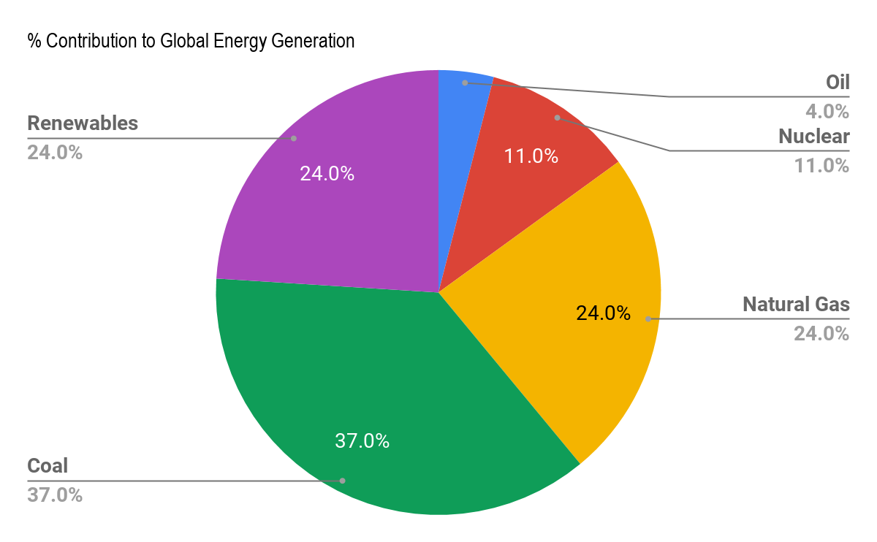

**Figure 1:** % contribution of each natural resource to Global Energy Generation

From the above data, almost 65% of Global Energy Generation comes from coal, oil, and natural gas. However, humans have increased the dependency on these natural resources so much that their reserves are not going to last forever. Although new reserves are being discovered and new technology is being developed to efficiently extract these reserves, the non-renewable resources can not be relied upon for power generation forever.

This idea has led to the explosion of a very detailed inquiry into the field of power generation through renewable sources of energy- wind energy, solar energy, hydel energy and tidal energy. Among these, hydel and wind energy have emerged as important sources of energy generation due to their surplus availability and higher efficiencies of energy transformation as compared to other sources such as tidal or solar energy [3]. This fact has made wind energy generation capacity as the focal point of this article.

**1.2 Wind Energy in India**

Wind is a renewable resource freely available along the Deccan coastline in India. Advancements in wind power generation technology has led to an increase in the amount of installed wind power generation turbines. Many nations have made plans to make large investments in wind power in near future. [3]

In India, renewable energy accounts for nearly 12% of the entire energy demand. Coal tops this list with 56% contribution, with natural gas and hydropower being the next sources with 9% and 19% contribution respectively [5]. As discussed, the depletion of exhaustible resources in future is ought to increase pressure on the renewable resources.

In the year 2016-17, the electrical demand was about 1392 TWh (with a peak demand of 218 GW) [5]. This electrical demand is expected to increase in the coming years as India moves towards a digital and technological revolution. As an estimation, the electrical demand is anticipated to be at least 1915 TWh (peak electric demand of 298 GW) in 2021-22 [5]. A significant pressure of this electrical demand is expected to fall on the power generated from renewable resources in the country.

India is indeed growing in the field of renewable power generation, specially wind power generation. A total of 28700 MW of wind power capacity was installed in the country by the end of December 2016, and this increased to a total of 31177 MW by the end of March, 2017 [5]. However, this capacity is still not enough. According to IEA project, India will need about 327 GW power generation capacity in 2020 [5]. And wind energy is an important aspect of this target. India is the 3rd largest annual wind power market in the world and provides great business opportunities for both domestic and foreign investors [5]. India is therefore fully capable of achieving the target power production suggested by the IEA project by making more determined moves in this direction.

However, a big problem in achieving this aim is that many states in India are not producing wind power to their full potential [5]. These states have sites with good wind power generation potential, but most of these sites have old and inefficient wind turbines [5].

The prime objective of this article is to analyze wind power generation potential in large wind farms in India in order to meet the target suggested by the IEA project. If India succeeds in overcoming the aforementioned shortcomings in wind power production, it can generate close to 81 TWh each year by 2020 and close to 174 TWh by 2030 [5]. An added benefit of this increased use of efficient wind turbine designs is the reduction of the greenhouse gas: carbon dioxide. It is quantified that nearly 48 million tons of carbon dioxide can be saved from emission in 2020 and nearly 105 million tons in 2030 [5]. In a world of severe environmental crisis, this is a huge reduction in carbon dioxide emission, and it needs to be targeted for the safe future of the environment.

**2.0 Methods**

**2.1 Initial Setup**

This study has been done by a simulation-experiment of setting up a model of a wind turbine at various places along the Deccan coastline and then using a simulation software to quantify the results and compare them with actual power generation statistics. The turbine used for this study is GE 1.5XLE turbine, which is one of the latest and efficient designs in wind turbine industry.

**2.2 Target sites**

Several sites that deploy large scale wind turbines and have reliable source of details about the wind farm and wind speed variations over a long period of time are also considered in this study (Table 2).

**2.3 Turbine Blade Design Methodology**

Before proceeding to simulating the results, the real-world turbine has to be modeled into the software described in step 2.4.

The turbine design parameters are graphed as a function of wing span (in metres) in the figure presented below: [7][8]

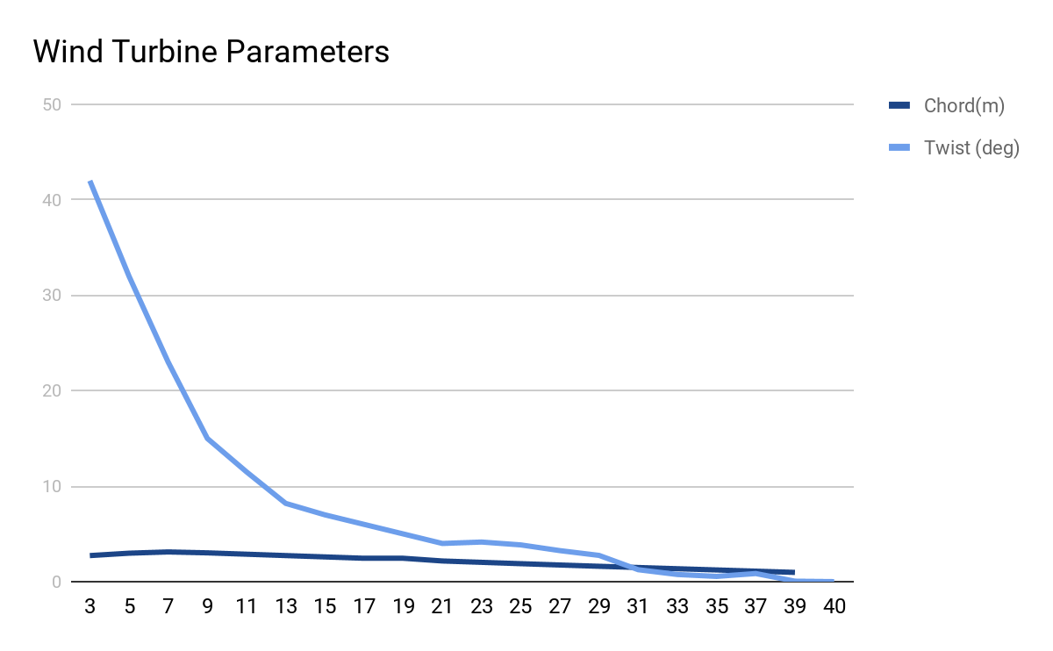

**Figure 2** - Graph of Chord length and twist angle on the vertical axis against the turbine radius on the horizontal axis

The blade model used in this study is 43.2 metres in radius. The hub at the centre is joined to the blade using a cylindrical root section. The entire blade is divided into three blade profiles: S818 (for root), S825 (for body), and S826 (for tip). These airfoils mark the transition of the blade from the cylindrical root to the body and tip.[8]

Extrapolating the data in the graph in Figure 2, it is found that the twist and the pitch angle for a blade span of 43.2 metres should be 4 degrees at the blade tip.

**2.4 Simulation Methodology**

There has always been a requirement of prediction techniques that can accurately predict the performance of multiple turbine installations within a specific local environment and operating in a range of local conditions. Earlier, scaled prototypes of the aerofoil to be analyzed were created and placed in large wind tunnels to stimulate real world working conditions. Sensors were placed at different points in the tunnel to record data. [9]

This method was costly and time-taking. As an alternative, Computational Fluid Dynamics yields reliable computer-based results that can effectively be applied to real-world conditions. The following procedure is followed in a typical CFD study:

1. The geometry of the simulation is defined based on the real world structure of the thing to be simulated.
2. Meshing is done. In this, the volume of the geometry is divided into discrete cells.
3. Governing equations are written down. These model the flow as it happens in the real-world.
4. Boundary conditions are set.
5. Simulation is done for a number of iterations until the solution successfully converges.
6. A postprocessor (like CFD Post) is used to analyze results.

The software used for this study is ANSYS 19.1 [10] because it has several models (inviscid, laminar, k-w, and Spalart Allmaras) which can be compared and used for this study’s purpose. Furthermore, ANSYS is a powerful tool for solving the Navier-Stokes equation [11] which turns out to be the governing equation for the problem dealt with here (elaborated in 2.5).

**2.5 Underlying Physics involved**

The Governing Equations are the continuity equation (derived from the principle of conservation of mass) and Navier-Stokes equation. In order to compensate for the rotation of the blade (and avoid solving the very complex moving mesh problem due to the rotation of the blade [11]), the equations are written in a frame of reference rotating with the blade. This is done by inputting into ANSYS the rotational velocity of the rotor. This modifies the relative velocity of the wind compared to that of the blade and the Reynolds Number which in turn modifies the aerodynamic performance of the flow around the blades [11].

The equations hence used are:

1. *Conservation of mass (A form of continuity equation)*

$$\frac{dp}{dt}+\left(\frac{d}{dx}+\frac{d}{dy}+\frac{d}{dz}\right). ρ. v_{r}=0$$

*2*. *Conservation of momentum (Navier-Stokes Equation)*

$$∇.\left(ρ.v_{r.}v_{r}\right)+ ρ\left(2ω × v_{r} + ω×ω×r\right)= -∇p+ ∇.τ$$

where *p* is the momentum, $ρ$ is the density of the fluid flowing in the domain, $ω$ is the rorational velocity of the rotating frame of reference, $∇ = \left(\frac{d}{dx}+\frac{d}{dy}+\frac{d}{dz}\right)$, r is the radius of the blade and $v_{r}$ is the relative velocity.

In ANSYS Fluent, these differential equations are converted into a set of algebraic equations using piecewise linear approximation method. The solver inverts these equations to calculate velocities (in X, Y, and Z directions), momentum, and rotational velocity at the cell centers of the discrete cells formed in the meshing step. In the postprocessing step, the values at the cell centers are extrapolated to find values at all the points on the geometry.

To these governing equations are attached the boundary conditions as described in section 2.7. The periodicity assumption is used to divide the domain into three sectors of ${120}^{o}$. [12].

On this one-third of the geometry, the following parameters are initialized in the beginning of the solution:

* Inlet velocity- The incoming velocity of the wind
* Outlet pressure- 1 atmospheric pressure at the outlet of the flow domain

**2.6 Model (Geometry and Meshing)**

The geometry of the turbine was created using valuable inputs from [13] and [14].

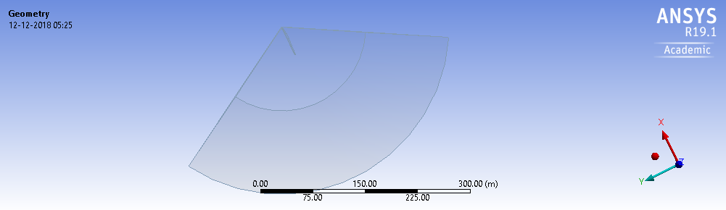

**Figure 3 :** The flow domain of the turbine modelled. Using the periodicity assumption discussion in section 2.5, only ⅓ portion of the entire circle has been modelled

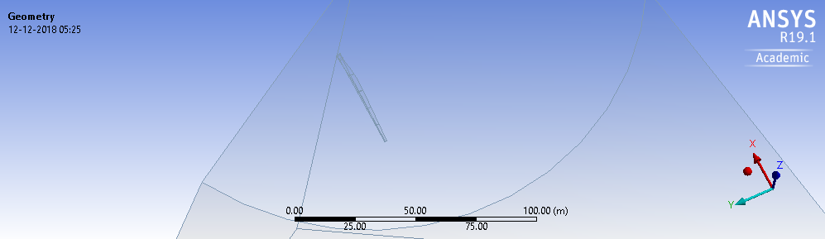

**Figure 4** depictsthe turbine blade modelled.

Figure 3 represents the blade and the one-third flow domain around it. Figure 4 is a zoomed-in version of Figure 3, depicting the blade and its segments that have been modelled in accordance with the measurements discussed above in Turbine Blade Design Methodology section.

To mesh the above geometry, two different coordinate systems are described: the Global Coordinate system (at the end of the blade) and the User defined coordinate system (at the center of the blade). The result is depicted in Figure 5.

The demarcation of coordinate systems is done for the *Body sizing mesh control system.* It requires a center for the *sphere of influence.* This center must be set to the point at the center of the blade for optimal results. Hence, defining a new coordinate system is a more judicious choice than picking the original coordinate system and translating it to the center of the blade. 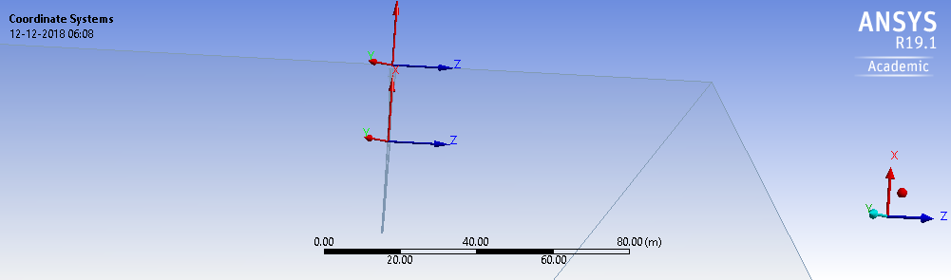

**Figure 5:** The Global and User-Defined coordinate systems created

Four different mesh control systems were introduced: match control, face sizing, inflation, and body sizing. A range of different combinations of these values were tested. The combination chosen was the one that gave maximum number of nodes and elements in the mesh, as well as decent mesh metrics (Skewness and Orthogonal quality are the mesh metrics used in this study [16]). Figure 6 illustrates the systems for the following values:

1. **Match control**: Cyclic transformation
2. **Face sizing:** Element size (5e-2 m); Defeature size (2.5e-2 m); Behaviour (Hard)
3. **Inflation:** Boundary (Blade [*see Named Selection*]); Inflation option(Smooth Transition); Transition ratio (0.272); Max. Layers (10); Growth Rate (1.2); Inflation Algorithm (Pre)
4. **Body sizing:** Type (Sphere of Influence); Sphere center (**User defined Coordinate system**); Sphere radius (50 m); Element size (1 m).

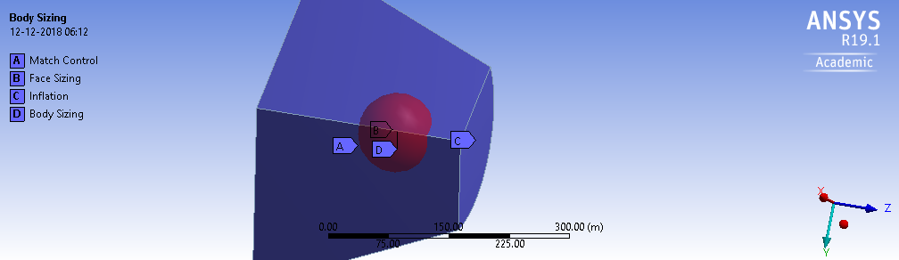

**Figure 6:** Depiction of Mesh Control systems in the flow domain

This combination results in the following mesh statistics:

1. Nodes: 1834742
2. Elements: 7061100

The following mesh metrics criteria has been used in this study (derived from information from [15])

**Skewness**

|  |  |  |  |  |  |  |
| --- | --- | --- | --- | --- | --- | --- |
| **Mesh quality** | Outstanding | Very good | Good | Sufficient | Bad | Inappropriate |
| **Range** | 0 - 0.25 | 0.25 - 0.50 | 0.50 - 0.80 | 0.80 - 0.95 | 0.95-0.98 | 0.98-1.00 |

##### **Skewness values:** Ranges of *skewness* mesh metric values to judge an element’s quality

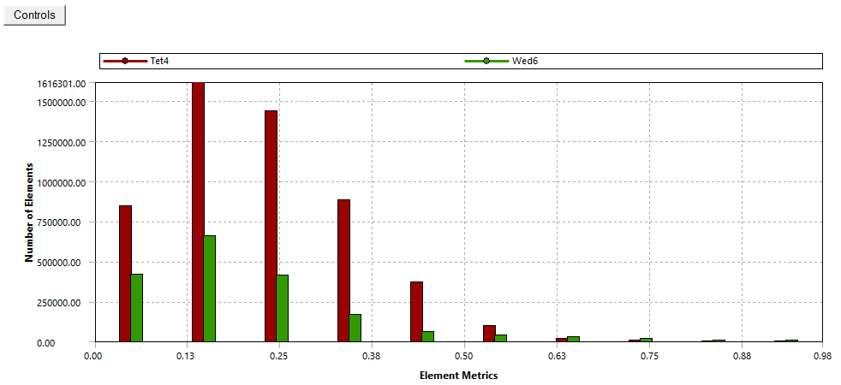

**Figure 7:** Depiction of number of elements against their Skewness value

Figure 7 depicts the Skewness metric for all the element in the mesh described. From the figure and skewness values, nearly all the elements are less than 0.5, and hence fall in the *Very Good* mesh quality according to the skewness values above. Moreover, average of skewness of all the elements is 0.21591 (that falls in the *Outstanding* mesh quality range) and standard deviation is 0.12625. It is therefore concluded that the mesh is of *very good* quality according to the skewness mesh metric.

##### **Orthogonal Quality:**

|  |  |  |  |  |  |  |
| --- | --- | --- | --- | --- | --- | --- |
| **Mesh quality** | Outstanding | Very good | Good | Sufficient | Bad | Inappropriate |
| **Range** | 0.95- 1.00 | 0.70-0.95 | 0.20-0.70 | 0.15-0.20 | 0.001-0.15 | 0-0.001 |

##### **Orthogonal Quality values:** Ranges of *orthogonal quality* mesh metric values to judge an element’s quality

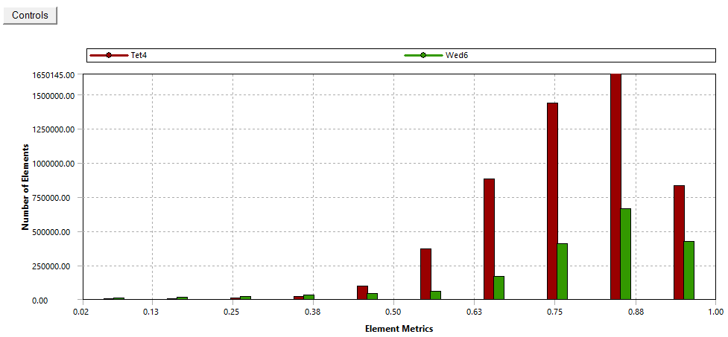

**Figure 8:** Depiction of number of elements against their Orthogonal Quality

Figure 8 depicts the orthogonal quality of all the elements of the mesh. From the figure and orthogonal quality values, most elements are above 0.5 and lie in the *Good - Outstanding* region of the orthogonal quality ranges described above. The mean is 0.78282 and standard deviation is 0.12597. Hence, this mesh is of *very good* quality and that it will give fairly accurate results when simulated upon.

**2.7 Model Setup for simulation**

The simulation methodology in this experiment would involve defining initial boundary conditions on various parts of the blade. To be able to achieve this, named selections in ANSYS were used. Named Selections in ANSYS allow different parts of the mesh to be recognized independently from each other and specific behaviours can be attached to those named selections in the model setup stage. The following named selections were defined for this particular mesh:

1. **Inlet, Inlet Top -** These define the regions that simulate the incoming fluid flow.
2. **Outlet -** This defines the region simulating the outgoing fluid flow.
3. **Period 1, Period 2-** These define the boundaries on which the periodicity condition was applied [12].
4. **Blade-** This models the real world blade of the GE 1.5XLE turbine
5. **Fluid -** This models the physical volume affected by the wind turbine

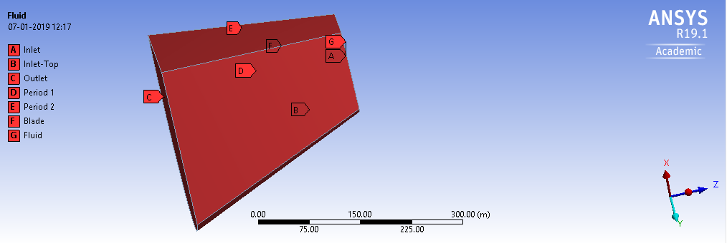

**Figure 9:** Named selections applied on the turbine geometry

ANSYS offers various viscous models to stimulate the real world flow of the fluid under consideration- inviscid, laminar, k-w, and Spalart Allmaras [10]. The inviscid model relies on the inherent assumption that the fluid is perfect (no viscosity and no turbulence) [11]. The laminar model inherently assumes that the fluid flow is turbulence free [11]. Both these models are rejected because they clearly do not conform to the real-world dynamics of fluid flow. On the other hand, k-w and Spalart Allmaras are found to give both accurate and approximately similar results. Hence, it is safe to interchangeably use both models [11].

For this study, the k-w omega (alternatively named SST k-omega) model is used because it adds two equations (kinetic energy and dissipation) to the Navier-Stokes equation. From [17], SST k-omega adds the following important equations:

**Turbulence Kinetic Energy**

$$\frac{∂k}{∂t}+U_{j}\frac{∂k}{∂x_{j}}= P_{k}- β^{*}kω+ \frac{∂}{∂x_{j}}\left[(v + σ_{k}v_{T})\frac{∂k}{∂x_{j}}\right]$$

**Specific Dissipation Rate**

$$\frac{∂w}{∂t}+ U_{j}\frac{∂ω}{∂x_{j}} = σS^{2} - βω^{2} + \frac{∂}{∂x_{j}} \left[\left(v+ σ_{w}v_{T}\right)\frac{∂ω}{∂x_{j}}\right] + 2\left(1- F_{1}\right)σ_{ω^{2}}\frac{1}{ω} \frac{∂k}{∂x_{i}} \frac{∂w}{∂x_{i}}$$

On the other hand, Spalart Allmaras model is a one equation model, containing only the Turbulence Kinetic Energy equation [18]. Energy dissipation on fluid flow is a ground truth in fluid dynamics of the real world. It is therefore better for this study to stick to the two-equation SST k-omega model.

The material used for the simulation was normal air, with ground truth values for density (= 1.225 $kg m^{-3}$) and viscosity (= 1.7894e-05 $kg m^{-1}s^{-1}$). The cell zone conditions had the *Frame motion* option selected, which allowed manual entry of rotational velocity of the frame of motion. The inputs were taken from data as described in section 3.

The following boundary conditions were applied to the Named Selections discussed above:

1. **Inlet, Inlet-top:** Both are thevelocity inlets. The velocities were described in the absolute frame of reference using separate values for all three coordinate directions (x, y, z). Values entered are tabulated in data in section 3.
2. **Outlet:** This is the pressure outlet. To stimulate real world conditions, gauge pressure of 0 atm was used. This equals the ideal normal pressure of 1 atm on the outlet.
3. **Period 1, Period 2:** These are the interfaces: the boundaries on which the periodicity condition (as discussed in section 2.5 and in [12]) is applied. This implies calculations done on one-third of the flow domain (${120}^{о}$) can be tripled to find results for the entire flow domain. This saves precious computing resource because number of equations to be solved goes down to one-third, still giving accurate results.
4. **Blade:** Blade is a wall and the fluid flow is considered only *along* its surface.
5. **Fluid-** Fluid is the interior of the fluid flow domain.

Before running the simulation, certain residuals were set. These described the tolerance level using which convergence was judged [19]. The SST k-omega model used the following residuals: continuity, x-velocity, y-velocity, z-velocity, k, and omega. All these were set to 1e-06 (which is considered a safe value in ANSYS to declare convergence [19]).

Some other settings used to fasten the process of convergence were:

* *Scheme for pressure-velocity coupling*: Coupled
* Spatial Discretization:
  + *Gradient* - Least Squares Cell Based
  + *Pressure* - Standard
  + *Momentum* - Second Order Upwind
  + *Turbulent Kinetic Energy* - First Order Upwind
  + *Specific Dissipation Rate* - First Order Upwind

Other conditions used were *Pseudo Transient* (under *Transient Formulation*) and relaxing Higher Order terms.

**3.0 Calculation and Data collection**

From the discussion of the wind turbine parameters in the section 2.3, it is mandatory to maintain a reasonable wind tip ratio (when given a certain wind turbine swept area) [20]. The tip speed ratio is defined as the relationship between rotor blade velocity and relative wind velocity. For GE 1.5XLE with a radius of 44.2 m (including the hub offset), a reasonable wind tip ratio is 8.

Considering a certain wind velocity $V m s^{-1}$ (in the negative z-direction).

From [20] and ground knowledge, the equation is:

$λ =\frac{ΩR}{V}$

Where, $λ$ is the wind tip ratio, $λ$ = 8 was used. $Ω$ is the rotational velocity as described in the Frame motion in section 2.5. This rotational velocity needs to be calculated. R is the radius of the wind turbine being used (= 44.2 m which is 43.2 m being the radius of the blade and 1m cutoff considering the hub). For different values of incoming wind velocities V $m s^{-1}$, $Ω$ is calculated. In the real world, this implies running the rotor with the calculated rotational velocity in order to give stability to the turbine by ensuring requisite wind tip ratio (~ 8).

The following data was collected (generation of one data point can take varied time depending on the system configuration and hardware. On *AMD A6-7310 APU with AMD Radeon R4 Graphics- 2 GHz* processor and 3.47 GB usable RAM, one data point generation took ~ 3.5 hours):

|  |  |  |  |  |  |  |  |  |  |  |  |  |
| --- | --- | --- | --- | --- | --- | --- | --- | --- | --- | --- | --- | --- |
| TR | WV | TR | Vx | Vy | Vz | ⍵ | Res | PT | VT | ST | TT | Power |
| 8 | 3 | 44.2 | 0 | 0 | -3 | -0.5429864253 | 1.00E-06 | -19292.5183 | 1412.0334 | -17880.4849 | -53641.4547 | 29126.58174 |
| 7.9 | 3.5 | 44.2 | 0 | 0 | -3.5 | -0.633484163 | 1.00E-06 | -22812.069 | 1853.3428 | -20958.7262 | -62876.1786 | 39831.06337 |
| 8 | 4 | 44.2 | 0 | 0 | -4 | -0.7239819 | 1.00E-06 | -26910.7212 | 2345.8392 | -24564.882 | -73694.646 | 53353.58983 |
| 8 | 4.5 | 44.2 | 0 | 0 | -4.5 | -0.814479638 | 1.00E-06 | -31559.252 | 2890.2035 | -28669.0485 | -86007.1455 | 70051.06873 |
| 8 | 5 | 44.2 | 0 | 0 | -5 | -0.90314 | 1.00E-06 | -36934.3151 | 3466.4971 | -33467.818 | -100403.454 | 90678.37545 |
| 8 | 6 | 44.2 | 0 | 0 | -6 | -1.0859728 | 1.00E-06 | -48906.2675 | 4814.3395 | -44091.928 | -132275.784 | 143647.9035 |
| 8 | 7 | 44.2 | 0 | 0 | -7 | -1.2669683 | 1.00E-06 | -63307.1827 | 6332.5087 | -56974.674 | -170924.022 | 216555.3176 |
| 8 | 8 | 44.2 | 0 | 0 | -8 | -1.447963801 | 1.00E-06 | -79991.4452 | 8033.2262 | -71958.219 | -215874.657 | 312578.6889 |
| 8 | 9 | 44.2 | 0 | 0 | -9 | -1.628959276 | 1.00E-06 | -99147.4963 | 9910.4693 | -89237.027 | -267711.081 | 436090.4487 |
| 8 | 9.2 | 44.2 | 0 | 0 | -9.2 | -1.665158 | 1.00E-06 | -103218.508 | 10306.864 | -92911.644 | -278734.932 | 464137.7019 |
| 8 | 9.4 | 44.2 | 0 | 0 | -9.4 | -1.701357 | 1.00E-06 | -107281.496 | 10710.37 | -96571.126 | -289713.378 | 492905.8837 |
| 7.9 | 9.6 | 44.2 | 0 | 0 | -9.6 | -1.737556561 | 1.00E-06 | -111541.877 | 11120.463 | -100421.414 | -301264.242 | 523463.6603 |
| 8 | 10 | 44.2 | 0 | 0 | -10 | -1.809954 | 1.00E-06 | -120211.922 | 11961.184 | -108250.738 | -324752.214 | 587786.5687 |
| 8 | 11 | 44.2 | 0 | 0 | -11 | -1.99095 | 1.00E-06 | -143910.366 | 14180.866 | -129729.5 | -389188.5 | 774854.8441 |
| 8 | 12 | 44.2 | 0 | 0 | -12 | -2.22 | 1.00E-06 | -159429.523 | 17458.043 | -141971.48 | -425914.44 | 945530.0568 |
| 7.9 | 12.2 | 44.2 | 0 | 0 | -12.2 | -2.208 | 1.00E-06 | -175142.423 | 17062.353 | -158080.07 | -474240.21 | 1047122.384 |
| 8 | 12.4 | 44.2 | 0 | 0 | -12.4 | -2.2443439 | 1.00E-06 | -180699.119 | 17568.809 | -163130.31 | -489390.93 | 1098361.548 |
| 7.9 | 12.6 | 44.2 | 0 | 0 | -12.6 | -2.280542986 | 1.00E-06 | -186389.389 | 18079.169 | -168310.22 | -504930.66 | 1151516.075 |
| 7.9 | 12.8 | 44.2 | 0 | 0 | -12.8 | -2.316742081 | 1.00E-06 | -192018.059 | 18595.789 | -173422.27 | -520266.81 | 1205324.012 |
| 8 | 13 | 44.2 | 0 | 0 | -13 | -2.352941176 | 1.00E-06 | -197889.309 | 19113.989 | -178775.32 | -536325.96 | 1261943.435 |
| 7.9 | 13.2 | 44.2 | 0 | 0 | -13.2 | -2.389140271 | 1.00E-06 | -203799.675 | 19643.795 | -184155.88 | -552467.64 | 1319922.687 |
| 8 | 13.4 | 44.2 | 0 | 0 | -13.4 | -2.425339367 | 1.00E-06 | -209814.637 | 20179.887 | -189634.75 | -568904.25 | 1379785.874 |
| 8 | 13.6 | 44.2 | 0 | 0 | -13.6 | -2.461538462 | 1.00E-06 | -215824.234 | 20719.884 | -195104.35 | -585313.05 | 1440770.585 |
| 8 | 13.8 | 44.2 | 0 | 0 | 13.8 | -2.497737557 | 1.00E-06 | -222008.191 | 21268.791 | -200739.4 | -602218.2 | 1504183.016 |
| 8 | 14 | 44.2 | 0 | 0 | -14 | -2.533936652 | 1.00E-06 | -228282.211 | 21824.091 | -206458.12 | -619374.36 | 1569455.392 |

**Table 1:** Data collected from the simulation experiments

TR - Wind Tip Ratio

WV - Wind velocity

TR - Turbine Radius

Vx - X component of inlet velocity (m/s)

Vy - Y component of inlet velocity (m/s)

Vz - Z component of inlet velocity (m/s)

⍵ - the rotational velocity of the rotor in rad/s

Res - the residuals under consideration (discussed above in section 2.7)

PT - Pressure component of the torque (for one blade)

VT - Viscous Component of the torque (for one blade)

ST - Sum of PT and VT (for one blade)

TT - Total torque on the three blades ( = $3 × ST$ [8] and refer to section 2.7 *Boundary conditions* *point c* for periodicity assumption.)

Power - Total power output of the turbine (= )

4. **Results** **and** **Discussion:**

Several monitors were set up to observe the convergence of the solution with time.

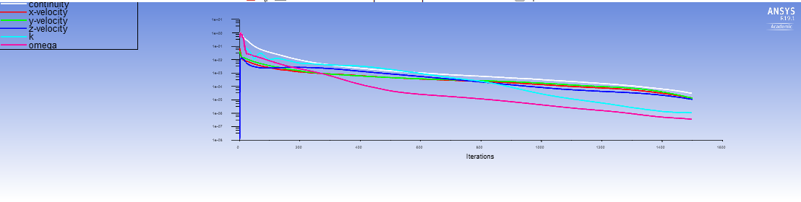

**Figure 10:** Observing convergence of variables*

* - The variables included in this monitor are: continuity, x-velocity, y-velocity, z-velocity, k, and omega. These converge to the optimum solution as in Figure 11:

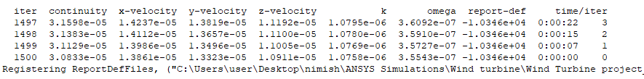

**Figure 11:** Values of variables in Figure 10 after convergence

With respect to the discussion about residuals in section 2.7, it is inferred that all these variables have converged significantly [19] and the results of the simulation can be relied upon.

Another monitor setup before running the simulation was the *integral static pressure* monitor. Convergence of the integral static pressure to $0 Pa m^{-2}$ is observed from Figure 12.

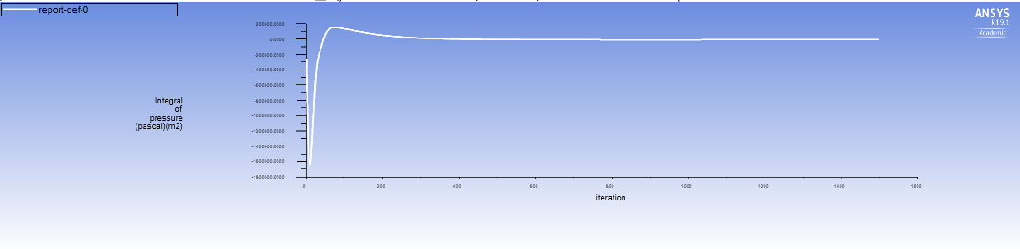

**Figure 12:** Convergence graph of Integral Static Pressure

Figure 13 shows the mass flow rate report, which calculates the difference between the incoming mass per unit time and the outgoing mass per unit time. From the figure, the mass flow rate is -0.21512808. This implies the simulation adheres to the real world condition where the wind turbine doesn’t hold back any mass that enters the flow domain.

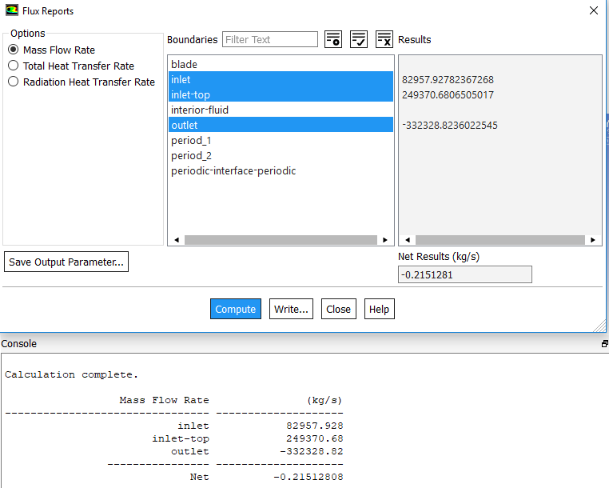

**Figure 13:** Mass Flow Rate report

Now since sanity checks done on the simulation results have yielded satisfactory results, a polynomial regression model was trained on the above data in section 3, table 1 to output predicted power for any given value of wind velocity (in $m s^{-1}$). Plotting the dependent (total power output) and the independent (wind velocity) variables on a scatter plot, the following figure is obtained:

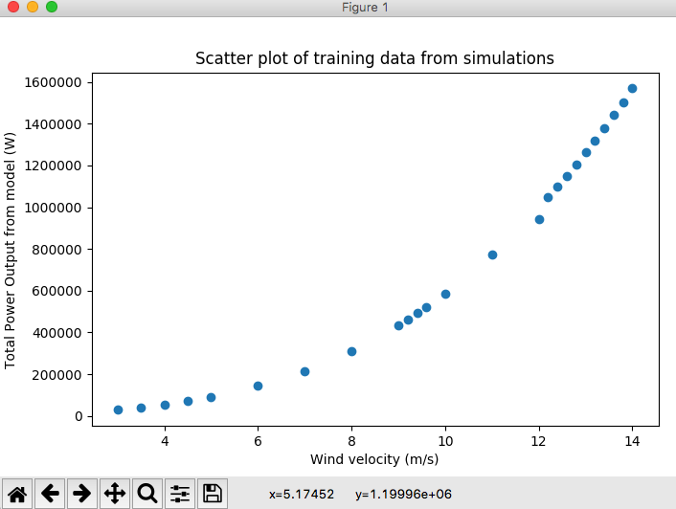

**Figure 14:** Variation of total power output with wind velocity

**(Output rated speed according to model: 14 m/s)**

Based on the results from [23], polynomial regression is an able alternative to neural networks. Moreover, scikit-learn [24] (a leading python library about various machine learning algorithms) offers a very convenient way to implement polynomial regression. This technique involves adding polynomial features based on the input features, viz. wind velocity. Scikit learn offers the *PolynomialFeatures* function under the *sklearn*.*preprocessing* module that can be used to add the aforementioned features based on the highest degree of the polynomial required. In Python, the process to achieve the same is:

1. Import *PolynomialFeatures* from *sklearn.preprocessing*
2. Scale down the output label (total power output) by a factor of (${10}^{6}$) to speed up training
3. Apply a degree 2 transformation onto the train data

Post this transformation, *LinearRegression()* module from sklearn was made to fit the training data. The line of best fit was plotted as in Figure 15:

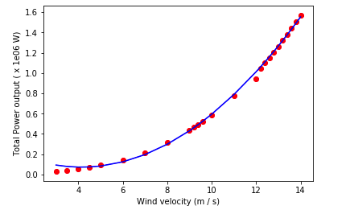

**Figure 15:** Line of best fit on the training data from section 3

Below is a list of various sites along the Deccan coastline in India (having large scale turbine and reliable source of information about the constitution of the wind farm and wind speed variations in a long period of time). The wind velocities considered are the average hourly gusts in the specific region in its most productive period of the year.

|  |  |  |  |  |  |  |
| --- | --- | --- | --- | --- | --- | --- |
| Site name | Number of turbines [28] | Power Output (MW) [28] | Wind velocity (m/s)[29] | Power output predicted for one turbine(MW) | Total predicted output (MW) | Remarks about site |
| Anantapur | 132 | 277 | 12.3 | 1.08550669 | 143.2868831 | Better site (uses Suzlon S97/2100) |
| Andra Lake | 142 | 107.6 | 11 | 0.78779884 | 111.8674353 | **Can improve with GE 1.5XLE** |
| Arikhana | 7 | 9.5 | 13.6 | 1.43486352 | 10.04404464 | **Somewhat improvement** |
| Baramsar | 31 | 22.5 | 12.6 | 1.16154327 | 36.00784137 | **Can greatly improve with GE 1.5XLE** |
| Bhakrani | 18 | 14.4 | 11.2 | 0.83023828 | 14.94428904 | **Can improve with GE 1.5XLE** |
| Belgaum | 31 | 24.8 | 11.8 | 0.96489137 | 29.91163247 | **Can improve with GE 1.5XLE** |
| Bhanwad | 25 | 52.5 | 12.3 | 1.08550669 | 27.13766725 | Better site (uses Suzlon S95/2100) |
| Bharmasagar | 23 | 37.9 | 12.2 | 1.0607724 | 24.3977652 | Better site(Vestas V82/1650) |
| Bhogat | 7 | 8.7 | 12.7 | 1.18750003 | 8.31250021 | **Can improve with GE 1.5XLE** |
| Bhuj | 34 | 51 | 13.8 | 1.49319496 | 50.76862864 | **Nearly the same performance.** |
| Budh | 20 | 30 | 13.6 | 1.43486352 | 28.6972704 | **Nearly the same performance.** |
| Burgula | 44 | 37.4 | 11.8 | 0.96489137 | 42.45522028 | **Can improve with GE 1.5XLE** |
| Chakala | 146 | 182.5 | 13.1 | 1.29438321 | 188.9799487 | **Can improve with GE 1.5XLE** |
| Chandgarh | 46 | 92 | 13.1 | 1.29438321 | 59.54162766 | Better site (Gamesa G97/2000) |
| Chilarewadi | 50 | 75 | 13.2 | 1.32186804 | 66.093402 | **Nearly the same performance. A better mesh can shed more light.** |
| Jaisalmer | 59 | 118 | 13.6 | 1.43486352 | 84.65694768 | Better site (Turbines of Inox Wind) |
| Dhalgaon | 130 | 162.5 | 13.3 | 1.34965849 | 175.4556037 | **Can improve with GE 1.5XLE** |
| Dhule-Nandurbar | 60 | 75 | 13.5 | 1.40615623 | 84.3693738 | **Can improve with GE 1.5XLE** |
| Essar | 67 | 100.5 | 13.6 | 1.43486352 | 96.13585584 | **Nearly the same performance. A better mesh can shed more light.** |
| Galad | 4 | 5 | 12.3 | 1.08550669 | 4.34202676 | **Can improve with GE 1.5XLE** |
| Gajendragad | 25 | 15 | 12.7 | 1.18750003 | 29.68750075 | **Can improve with GE 1.5XLE** |
| Gudepachgan | 63 | 37.8 | 11.5 | 0.89618956 | 56.45994228 | **Can greatly improve with GE 1.5XLE** |
| Harti | 39 | 31.2 | 12.2 | 1.0607724 | 41.3701236 | **Can improve with GE 1.5XLE** |
| Jangi | 40 | 60 | 12.7 | 1.18750003 | 47.5000012 | Better site (Suzlon S82/1500) |
| Kavadya Dongar | 57 | 57 | 12.8 | 1.2137624 | 69.1844568 | **Can improve with GE 1.5XLE** |
| Kazugumalai | 51 | 40.8 | 12.5 | 1.13589213 | 57.93049863 | **Can improve with GE 1.5XLE** |
| Khandke | 135 | 108 | 11.3 | 0.85191642 | 115.0087167 | **Can improve with GE 1.5XLE** |
| Kondamedapally | 68 | 54.4 | 12 | 1.01222065 | 68.8310042 | **Can improve with GE 1.5XLE** |
| Koralahalli | 38 | 22.8 | 11.7 | 0.94168515 | 35.7840357 | **Can improve with GE 1.5XLE** |
| Kukru | 25 | 50 | 11.9 | 0.9884032 | 24.71008 | Better site (Gamesha G97/2000) |
| Kutch | 24 | 50.4 | 12.3 | 1.08550669 | 26.05216056 | Better site (Suzlon G97/2100) |
| Lahori | 46 | 92 | 12.7 | 1.18750003 | 54.62500138 | Better site (Inox Wind DF 100) |
| Lalpur | 63 | 50.4 | 12.6 | 1.16154327 | 73.17722601 | **Can improve with GE 1.5XLE** |
| Ludarwa | 90 | 76.5 | 11.8 | 0.96489137 | 86.8402233 | **Can improve with GE 1.5XLE** |
| Mahidad | 63 | 50.4 | 12.1 | 1.03634372 | 65.28965436 | **Can improve with GE 1.5XLE** |
| Mamatkheda | 67 | 100.5 | 12.4 | 1.1105466 | 74.4066222 | Better site (Regen Powertech Vensys V87) |
| Mandsaur | 36 | 28.8 | 12.2 | 1.0607724 | 38.1878064 | **Can improve with GE 1.5XLE** |
| Mahidad | 12 | 25.2 | 12.6 | 1.16154327 | 13.93851924 | Better site (Suzlon S88/2100) |
| Panchpatta | 24 | 36 | 13 | 1.26720399 | 30.41289576 | **Nearly the same performance (Suzlon S82/1500).** |
| Periyapatti | 66 | 99 | 13.6 | 1.43486352 | 94.70099232 | **Nearly the same performance (Regen Powertech Vensys V77/1500).** |
| Phoolwadi | 33 | 49.5 | 13.6 | 1.43486352 | 47.35049616 | **Nearly the same performance (Regen Powertech Vensys V82/1500).** |
| Ratlam | 85 | 170 | 13 | 1.26720399 | 107.7123392 | Better site (Inox Wind DF 93) |
| Sadawaghpur | 49 | 61.25 | 13.4 | 1.37775455 | 67.50997295 | **Can improve with GE 1.5XLE** |
| Samana | 111 | 88.8 | 11.3 | 0.85191642 | 94.56272262 | **Nearly the same performance** |
| Tejuva | 15 | 31.5 | 12.8 | 1.2137624 | 18.206436 | Better site (Suzlon S88/2100) |
| Vankusavade | 7 | 7 | 12.2 | 1.0607724 | 7.4254068 | **Can improve with GE 1.5XLE** |
| Welturi | 24 | 50.4 | 12.2 | 1.0607724 | 25.4585376 | Better site (Suzlon S97/2100) |
| Yelisirur | - | - | - | - | - | **GE Turbines already installed** |

**Table 2:** Comparison of real-world output and predicted output from the simulation

It is noted that most of the present large scale wind farms in India along Deccan coastlines can benefit by replacing their turbines with the GE 1.5XLE turbine.

5. **Discussion**

Results from the model simulated depend greatly upon the meshing of the model. From the discussion about Figure 7 and Figure 8, it is clear that the present mesh could be tuned even more, which could lead to better results (possibly closer to the actual output rated speed of the GE 1.5XLE turbine- 11.5 m/s). A better mesh quality implies more proximity to real world output from the turbine.

Moreover, data about most wind farms in India and wind speeds in that particular region is hard to gather as the present data is sparse and mostly from unreliable methods. Further research prospects could be to expand on the above observations by using data from other regions in India and documenting the results.

6. **Conclusion**

Based on the comparison between the results obtained from the simulation and the actual data from the wind farms, it is inferred that expanded use of CFD simulations can be a valuable part of a multidisciplinary effort to truly determine the medium term potential for wind power in India.

Such an effort would need to also incorporate added wind data, land use availability and input on economics and regulations, as well as compatibility with the Indian power grid.

**Acknowledgements**

The author has received much support from his mother, Mrs. Neelam Mishra, in the preparation and in the proof-reading of the manuscript.

This research did not receive any specific grant from funding agencies in the public, commercial, or not-for-profit sectors.

**List of References**

[1] World Coal Association. <https://www.worldcoal.org/coal/uses-coal/coal-electricity>

*[Last checked January 16, 2019]*

[2] Devarshi Tathagat. Dr. Ramesh D. Dod. *Role of Green Buildings in Sustainable Construction- Need, Challenges and Scope in the Indian Scenario*. IOSR Journal of Mechanical and Civil Engineering.

[3] Arun K.K., Navaneeth V.R, Sam Vimal Kumar S, Ajay R. *Analyzing the Effect of Dimples on Wind Turbine Efficiency Using CFD*. International Journal of Applied Engineering Research. (2018).

[4] Global Wind Energy Council. *Indian Wind Energy (A Brief Outlook).* 2016.

[5] Khare, Vikas & Nema, Savita & Baredar, Prashant. . *Status of solar wind renewable energy in India*. Renewable and Sustainable Energy Reviews. 27. 1–10. 10.1016/j.rser.2013.06.018. (2013)

[6] Load Generation and Balance Report, Central Electricity Authority, Ministry of Power, Government of India, 2011–12. Load Generation and Balance Report, Central Electricity Authority, Ministry of Power, Government of India, 2012–13

[7] P. J. S. and R. J. Crossley, “Wind Turbine Blade Design,” 2012.

[8] Vimal Kumar. *Analyzing the Effect of Dimples on Wind Turbine Efficiency Using CFD*. International Journal of Applied Engineering Research. 13. (2018).

[9] P.R. Ebert and D.H. Wod, “*The near wake of a model horizontal-axis wind turbine-I. Experimental arrangements and initial results*,” 1997

[10] ANSYS Academic (Version: 19.2) <https://www.ansys.com/en-in/academic/free-student-products>

[11] Y Khalil, L. Tenghiri, F. Abdi, A Bentamy. **‘***Efficiency of a small wind turbine using BEM and CFD***’** 2018 *IOP Conf. Ser.: Earth Environ. Sci.* 161 012028

[12] Wind Turbine Blade FSI <https://confluence.cornell.edu/pages/viewpage.action?pageId=262012979>

[13] [Schubel, P., Crossley, R. *Wind Turbine Blade Design Review*. Wind Engineering*,* 365-388](https://confluence.cornell.edu/download/attachments/262012983/Wind%20Turbine%20Blade%20Design.pdf?version=1&modificationDate=1411507086000&api=v2).  [(2012)](https://confluence.cornell.edu/download/attachments/262012983/Wind%20Turbine%20Blade%20Design.pdf?version=1&modificationDate=1411507086000&api=v2)

[14] Wind Turbine Blade FSI <https://confluence.cornell.edu/display/SIMULATION/Wind+Turbine+Blade+FSI+%28Part+1%29+-+Geometry> *[Last checked January 16, 2019]*

[15] ANSYS User’s FLUENT Guide

<http://www.afs.enea.it/project/neptunius/docs/fluent/html/ug/node167.htm> *[Last checked January 16, 2019]*

[16] ANSYS FLUENT best practice guidelines; Mesh Quality

<https://www.kth.se/social/files/57149285f27654646b25d53b/05-Quality-ANSYS.pdf> *[Last checked January 16, 2019]*

[17] ANSYS FLUENT guide: SST-k omega model

<https://www.cfd-online.com/Wiki/SST_k-omega_model> *[Last checked January 16, 2019]*

[18] Spalart, P. R. and Allmaras, S. R, "*A One-Equation Turbulence Model for Aerodynamic Flows*", AIAA Paper 92-0439. (1992)

[19] Judging Convergence: <http://www.afs.enea.it/project/neptunius/docs/fluent/html/ug/node833.htm#sec-judging-convergence> *[Last checked January 16, 2019]*

[20] Peter J. Schubel and Richard J. Crossley. *Wind Turbine Blade Design.* Energies2012, *5*, 3425-3449; doi:10.3390/en5093425

[21] Load Generation and Balance Report, Central Electricity Authority, Ministry of Power, Government of India, 2011–12.

[22] Load Generation and Balance Report, Central Electricity Authority, Ministry of Power, Government of India, 2012–13

[23] Xi Cheng, Bohdan Khomtchouk, Norman Matloff, Pete Mohanty. *Polynomial Regression as an Alternative to Neural Nets*. arXiv:1806.06850v2(2018)

[24] Scikit learn documentation: <https://scikit-learn.org/stable/> *[Last checked January 16, 2019]*

[25] C. Draxl, A. Purkayastha, and Z. Parker. *Wind Resource Assessment of Gujarat (India).* National Renewable Energy Laboratory. <https://www.nrel.gov/docs/fy14osti/61741.pdf> *[Last checked January 16, 2019]*

[26] Clean Development Mechanism. *Lalpur Project Design Document.*

[27] [Dataset] Windpower (Wind energy market intelligence). *Lalpur wind farm report.* <https://www.thewindpower.net/scripts/fpdf181/windfarm.php?id=27004> *[Last checked January 16, 2019]*

[28] [Dataset] Windpower (*Wind energy market intelligence*). Indian wind farms data. *[Last checked January 16, 2019]* <https://www.thewindpower.net/windfarms_list_en.php>

29. [Dataset] References for wind velocity data:

1. Sandeep Chinta, Arun Agarwal, C. Raghavendra Rao. *Wind Speed Model for Anantapur District, Western Andhra Pradesh, India.* International Journal of Innovative Research in Advanced Engineering (IJIRAE) [2014]
2. World Weather Online, Monthly Climate Averages<https://www.worldweatheronline.com/lang/en-in/chittoor-weather-averages/andhra-pradesh/in.aspx> *[Last checked January 16, 2019]*
3. Indiastat; Indiastat Month Wise Mean Wind Speed <https://www.indiastat.com/meteorological-data/22/weather-data/30130/month-wise-mean-wind-speed/30790/stats.aspx> *[Last checked January 16, 2019]*
4. Meteoblue Weather history: *[Last checked January 16, 2019]*  <https://www.meteoblue.com/en/weather/archive/export/india_el-salvador_3585481?daterange=2019-01-09+to+2019-01-16&params=&params%5B%5D=32%3B10+m+above+gnd%3B31%3B10+m+above+gnd&params%5B%5D=32%3B80+m+above+gnd%3B31%3B80+m+above+gnd&params%5B%5D=180%3Bsfc&utc_offset=-6&aggregation=hourly&temperatureunit=CELSIUS&windspeedunit=METER_PER_SECOND>